M.Tech (IS)

Cognitive Systems Group Project

ISS Chatbot

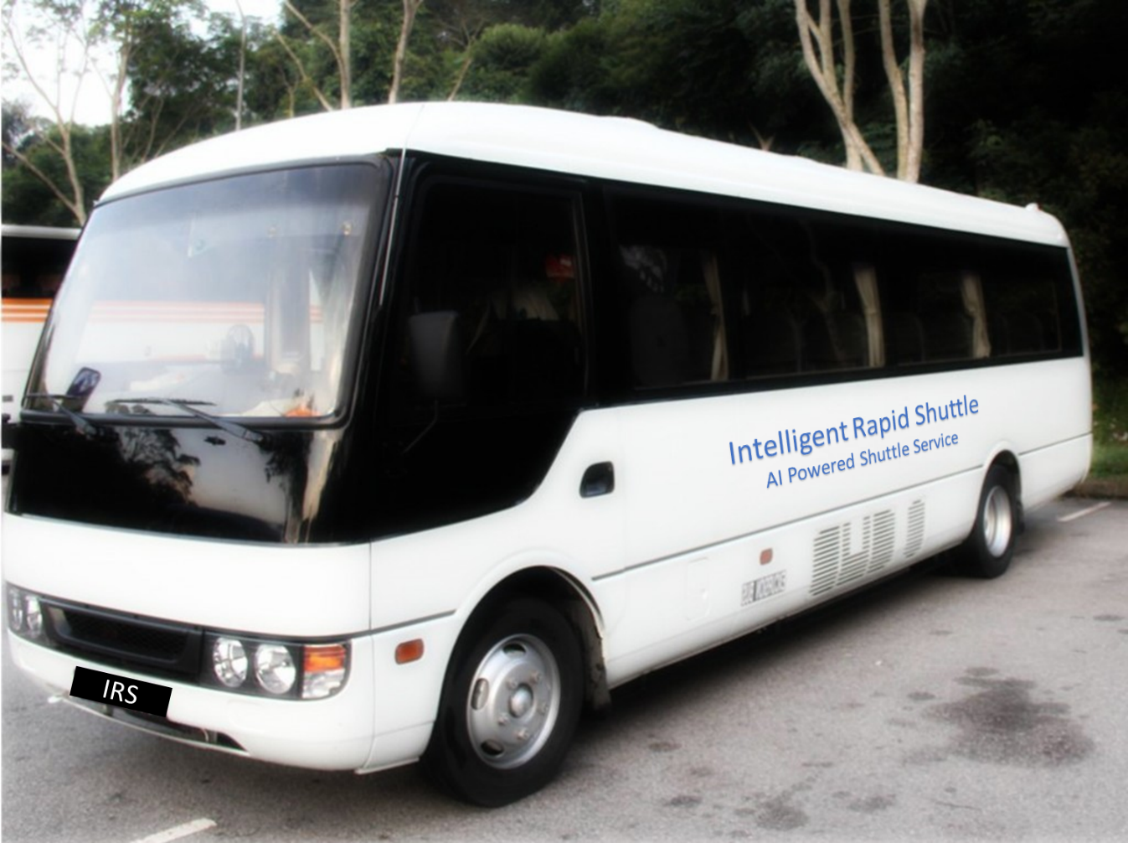

Team Members

SUDALAIANDI RAJA SUDALAIMUTHU

JAYARAMAN REVATHI

JAYASRI RAGHUNATHAN

SUNIL VARGHESE

# EXECUTIVE SUMMARY

NUS ISS offers a multitude of degree and professional conversion programs which are very popular not only in Singapore but also in many of the south east Asian and south Asian countries. Even within Singapore, IT is becoming a most sought-after subject, because of the emerging state-of-the-art technologies and the job and start up opportunities it provides.

The Singapore Government is making significant fund allocation for Skill future credits in its push for a smart nation. It aims to develop Infocom leaders who can achieve business & organisation innovation and also to ensure enough talent pool of employees for multinational companies in the thriving economy.

In order to meet the growing national and international demand, our team of 4 Singapore residents are tasked with building a chat bot which can handle queries of the aspiring students. This chatbot will provide a friendly user interface and will respond to users queries on ISS programs, courses and related information

Project Git Repository : <https://github.com/aivoyagers/IRS-RS-2019-03-09-IS1PT-GRP-aiVoyagers-irs-Intelligent-Rapid-Shuttle.git>

# BUSINESS PROBLEM BACKGROUND:

With multitude of courses offered, easy retrieval of relevant information is always challenging. The chatbot eases the effort through an intuitive natural language interface

# PROJECT OBJECTIVE

Having defined the business problem, our group’s aim was:

To develop a user-friendly chatbot, which can provide rapid and relevant responses on curriculum offered by NUS ISS. This will minimize efforts and time of the browsing multiple webpages. When the user enquires about such as course schedule and fee, the chatbot will recognize the intent and the entities and respond accordingly.

The Chatbot has built in voice and text-based conversational interfaces. It contains voice recognition, [natural language understanding](https://en.wikipedia.org/wiki/Natural_language_understanding), and text-to-speech. api.ai offers a web interface to build and test conversation scenarios.

# PROJECT SOLUTION

## BACKGROUND KNOWLEDGE AND USER INPUTS

For this project, below data/input are given/predefined:

User Input:

* Query on a specific ISS program

Data Collected from by web scrapping of ISS website on the following

* Executive Education
* Graduate Programmes
* Stackable Certificate programmes

## SYSTEM ARCHITECTURE

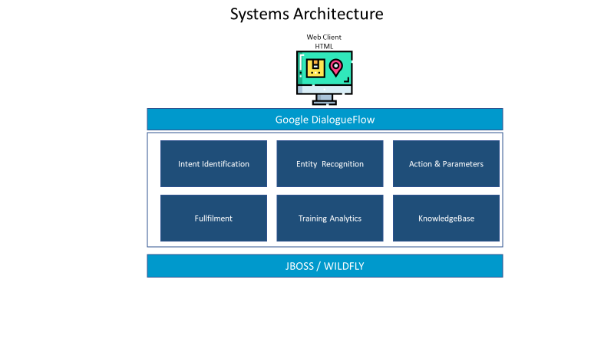

Below are the list of System components involved as part of this project.

* **IRS Web Client** is built using HTML/JavaScript to interact with user to get the user inquiry
* Google DialogueFlow will identify the intent and retrieve the information relevant to the entity present in the user input and return the response based on the information in the knowledgebase

# PROJECT SCOPE

Project scope is to develop, integrate and demonstrate speech and text recognition techniques by delivering a chatbot application. Objective is to demonstrate understanding of the concepts learnt in Cognitive Systems module as part of M.Tech (Intelligent Systems) graduate programme.

The scope of the project is limited to the following topics of the ISS website in the executive education, graduate programmes and stackable certificate programmes

ISS Chatbot project scope covers following minimum viable product features.

* A web user interface to accept user enquiry on the ISS programs offered
* It the recognise user intent as on ISS programs and identifies the entity
* If it can’t identify the intent, it will provide the Fallback intent

# SYSTEM’S FEATURES

Despite the limitations, the team went through an in-depth thought process to implement significant features in the Intelligent Rapid Shuttle system which can substantially add value to potential value to offer an AI powered optimized route path to achieve better service to customers at the same time operating at a lower cost with minimum possible total distance.

* Key differentiator is the ability to pick up students from various locations and service multiple schools at the same time. Same vehicle can service different schools optimizing vehicle capacity while achieving optimal travel distance for the students.
* The system optimizes the routes considering the student’s location to their respective destination (school) across all the students to be serviced and the available vehicles at disposal. This helps the students to reach school faster.
* The overall distance travelled by all the vehicles operating for the service provider is optimized such that the least distance is travelled. This would help the service provider to minimize the cost and hence price the services competitively.
* The soft score computed includes:
* Distance factor for each student from their starting location to to their respective school
* Distance factor for overall distance travelled by all vehicles available for service
* The capacity of the vehicles is optimized dynamically, such that at any given point of time capacity is maximized without crossing the capacity limit. This in turn helps in maximising the profit for the service provider.
* The system is designed for scalability, i.e. it caters for multiple vehicles with multiple locations as well as multiple student locations. The system is catered to have these inputs scaled up.

## IRS Solution – Sample Screen for the Data Input provided in Section 6.2 Sample Input

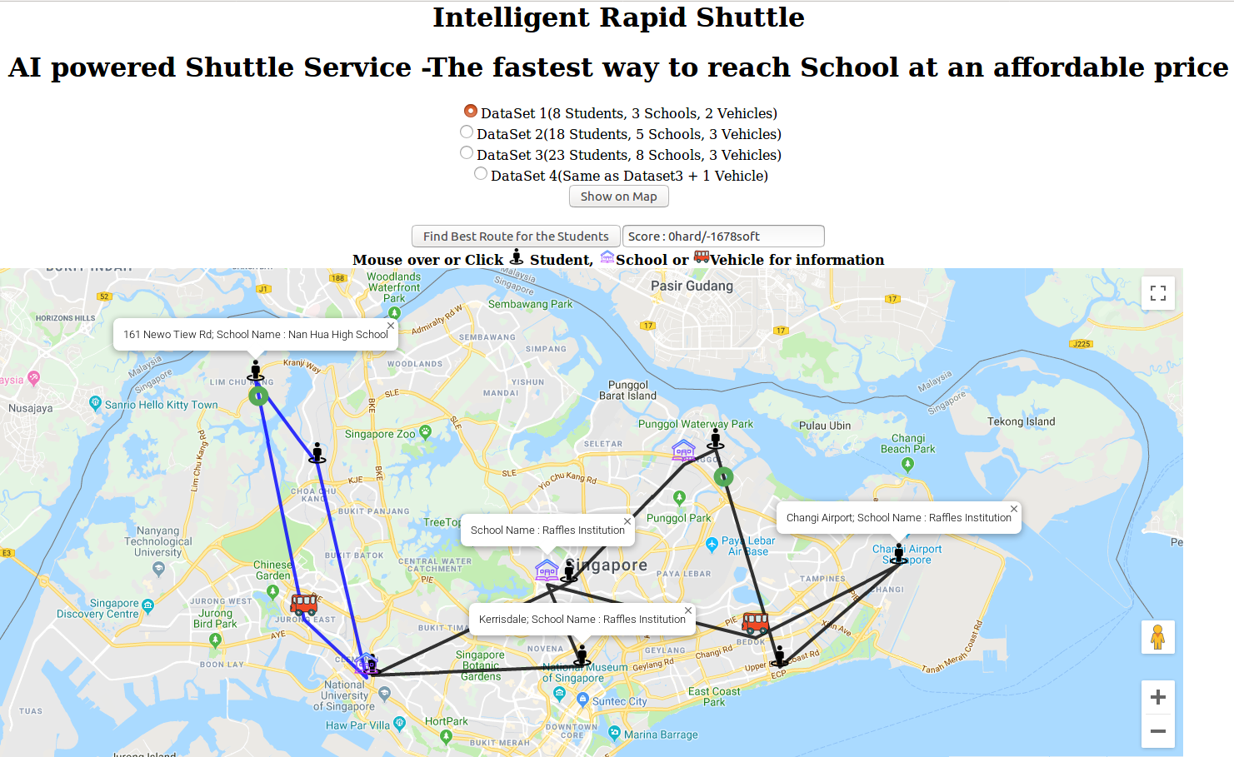

## IRS Solution – Sample Input

## IRS Solution – Sample Output

# LIMITATIONS

System will respond based in the information in the knowledge base. While it can answer individual questions, it will not be able to engage in a continuous dialogue, based on the previous answer. It will not answer questions other than the 3 topics mentioned earlier. This is due to the limited time available to web scrapping of the ISS website

# CONCLUSION

Our team had a great time working on this project, and we definitely picked up some useful skills along the way. Understanding the configuration of Dialogue flow, providing training utterances, annotating the entities and integrating the knowledge base. Without a sound knowledge base taught in the lectures, we wouldn’t have been able to build on system based on all the different rules. IMPROVEMENTS

Following are the improvements noted while executing this project.

* Compare with courses offered by other universities
* Address the limitation highlighted in Section 7 LIMITATIONS